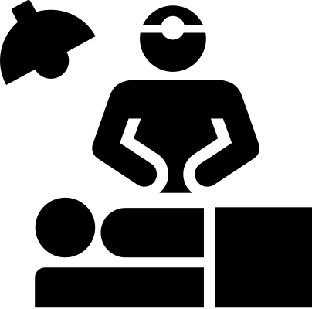

Surgical Subspeciality Shadowing Program

* **[INCLUDED SURGICAL SUBSPECIALTIES]**

Attend and participate in:

* operating room shadowing
* clinical shadowing
* surgery skills clinics

All experiences will be planned around your medical school schedule and will take place within the facilities of the **[NAME OF MEDICAL SCHOOL]** and **[NAME OF ASSOCIATED MEDICAL CENTER]**

Medical Student participants will be asked to complete the following tasks:

* Attend a one-time lunch orientation on **[DATE]**
  + Will last 45-60 minutes
* Complete Pre- and Post-SSEP surveys
  + Will take roughly 10-15 minutes
* Complete an online post-experience survey after each experience
  + Will take roughly 5 minutes

For additional information regarding this program please feel free to contact:

**[LEAD MEDICAL STUDENT(S) WITH THEIR CONTACT INFO]**